23rd October 2017

Location: SIM

Present: Eka, Mark, Lester Joel

## Review of Previous Meeting Minutes

*Briefed Lester on what happened the previous meeting*

### Actions items from previous minutes

|  |  |  |
| --- | --- | --- |
| **Previous Action Item** | **Person(s)** | **Status** |
| Send sample documentation, project plans, proposals | Lim De Yang | Unsent; Messaged on whatsapp |
| Proposal | Eka, Mark, Lester, Joel | Work in progress |

## [Discussion] Project Direction

### Initial Discussion – What should we be aiming for?

Eka suggests build app that people will want to use, should target teenage students

Mark suggests that we build an app that is both usable and fun (ideally)

Lester brought up that our task is to first recreate the functions of Krypto.exe:

**helps** to analyse ciphertext, does not actually perform decryption.

**3 major ideas presented themselves throughout our lengthy discussion:**

*(ideas that were being brought up were permutations of these)*

* Build a giant tutorial
  + Teach users cryptography
* Provide suggestions (guided usage)
  + Suggest what steps users should take based on ciphertext
* Game
  + Attempt to either make cryptography fun or provide extrinsic rewards such as points, achievements, etc

Mark suggested that we should go in the direction of building a tutorial styled app if our target audience has no prior knowledge of cryptography, or go simply provide a tool if they possess knowledge.

Lester & Mark suggested that we begin the project by first providing a GUI for Krypto, before adding a “help” section that explains what each function do

### Conclusion:

Target group: People have knowledge of basic cryptography; People who will require these cryptographic tools.

Direction: To build a cryptographic tool

Provide a GUI a Krypto

Provide additional features such as encryption and decryption on top of features already implemented in Krypto

(The suggestions system will be added if there is enough time)

## Use Case Diagram (Initial)

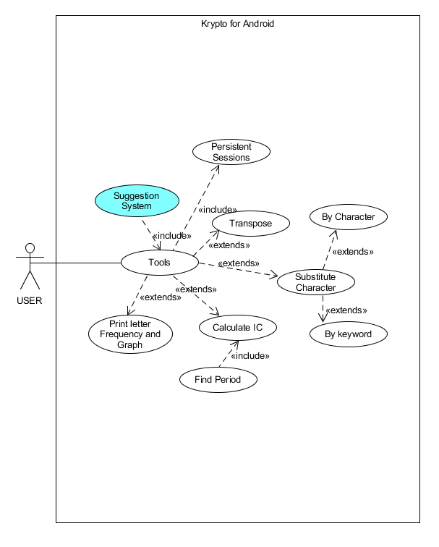

## Next meeting (26th Oct 2017)

Review previous meeting minutes

Look through samples from De Yang

Attempt to finish proposal

# 19th October 2017

Location: SP, Clementi KFC

Present: Lim De Yang, Mark, Eka, Joel

*First Meeting with Lim De Yang*

## Expectations / Logistics

* subsequent communications are to be made via face-to-face, whatsapp and email
* Mr Lim set up Google Drive for file sharing
* [Action] Mr Lim will share sample documentation, project plans and sample proposals
* [Action] We are to send our proposal by week 3

## Scope of Project

* App must compile on android device
  + Hybrid implementations are okay
  + Web apps are not okay
* Actual Use-Case is up to us
  + Must include ALL the functionality that Krypto.exe provides
  + Project must provide a superset of Krypto.exe features

*Internal Discussions*

## Repository/Collaborative Platform

* use Github to host our repository (lack of familiar alternatives)

## Project Requirements

* exist on android
* feature all the functions of Krypto
* be game

## Possible Features

* tutorial modes
* multiplayer / cross platform
* Allow user to perform encryption algorithm (user familiarity)